Location Troubleshooting for Windows 10 Tablet

Open Location Settings on your tablet
- There are two ways to get to Location Settings in Windows 10
  - Click on the Start (Windows button)  and then click on Settings (gear icon) on left. Click on “Privacy” and “Location” in the menu on the left-hand side.
  - Click on Search  and then type in ‘Location’
- Either of these steps will open the Location Settings.

Ensure Location Services are turned on
- In Location Setting makes sure that Location is turned on
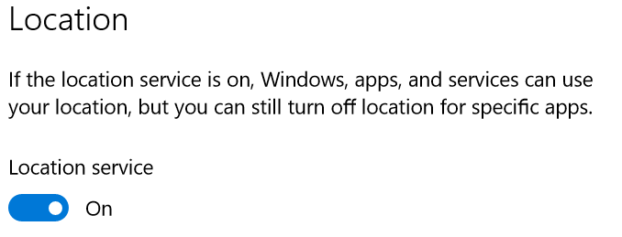
- Also make sure that Collector has access to your location. Scroll down halfway on the page to a heading called ‘Choose apps that can use your precise location’ and makre sure Collector is turned ON.
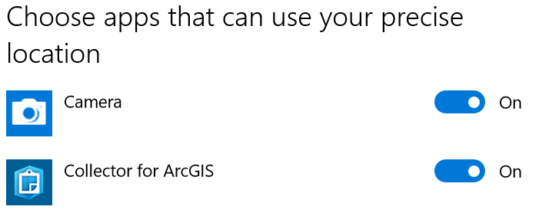

When apps are using your location
When an app is using your location, you will see the location icon appear in your menu bar next to the date and time. If you want that symbol to be visible, click the up arrow to expand menu bar options and drag and drop the location icon to a desired location on your tool bar.

Clear location history
- Sometimes your location may get cached (saved) and this can affect certain applications. To clear this, again open Location Settings.
- Scroll down a little bit to find the ‘Location history’ heading. Click CLEAR.
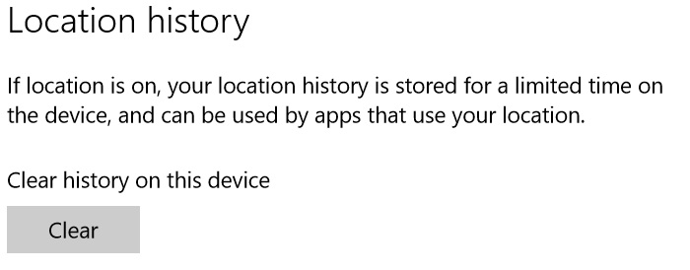

Enable location in your browser
- In Chrome – click on the Menu icon in the top right and then click on ‘Settings’
- Type location in the search bar at the top 
- Find ‘Content Settings’ in the list (towards the bottom) and click on it.
- Next click on ‘Location’ in the list 
- On the Location page, ensure that TAMS is in the allowed list. If it is not, you will need to go to TAMS and try to get the location and then when prompted – ‘Allow’ the page to access location.
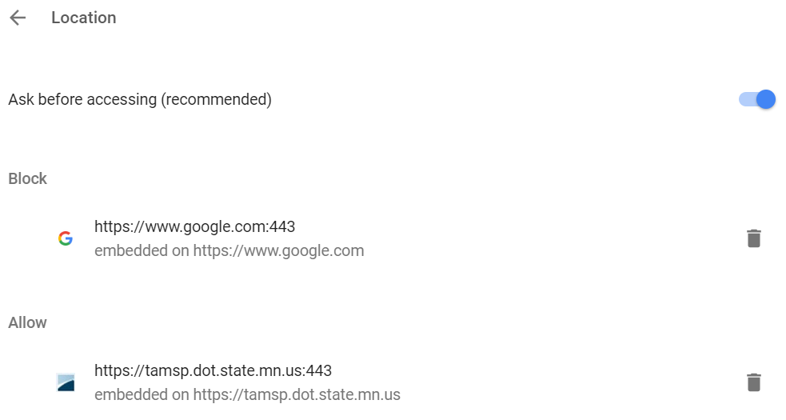

- In Internet Explorer, click on Settings in the top right 
- Then click on ‘Internet Options’
- Click on the ‘Privacy’ tab and check to see that location is not blocked – needs to be UNCHECKED
